How to use Fingerprint in Jenkins?

This is useful if we have multiple builds and to find out the project and snapshot id versions for the jar.

1. Archive the artifacts
2. Use the fingerprint option
3. Download the file
4. Check the file in fingerprints section

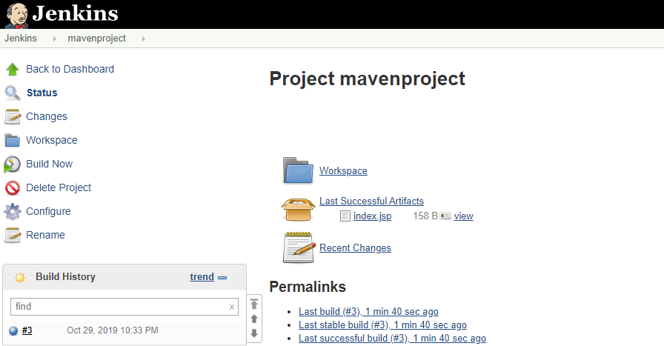

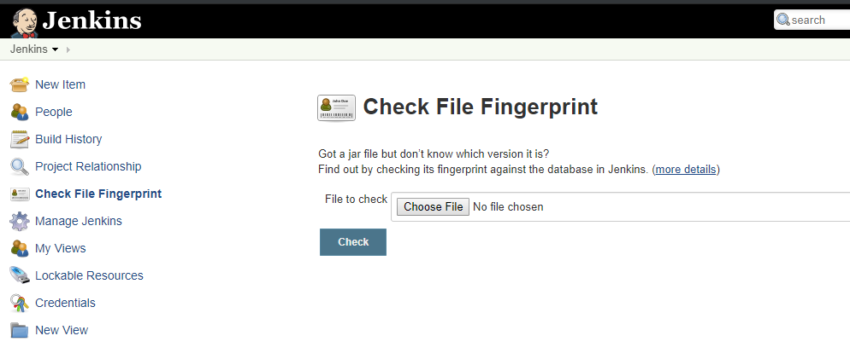

We can check the usage:

